Evenness analysis

# Introduction

Biodiversity loss has serious implications for ecosystem functioning (Tilman et al. 2014). Traditionally biodiversity has mostly been quantified in terms of species richness (Chapin et al. 2000)(Hooper et al. 2005)(Gotelli & Colwell 2011). However, biodiversity can also be quantified in terms of evenness of species abundances. Evenness contains potentially useful biodiversity information, as it affects ecosystem functioning such as production, decomposition and invisibility (Wilsey & Potvin 2000)(Hillebrand et al. 2008) (Wittebolle et al. 2009) (Ward et al. 2010).

How evenness relates to species richness is a contentious issue. Theoretically, evenness and species richness should be independent (Hill 1973)(Peet 1974). Empirical evidence suggests otherwise, with many studies reporting a positive relationship e.g. (Feio et al. 2010) (Zhang et al. 2014) (Passy 2016) (Wang et al. 2017). The usefulness of evenness as a concept has even been called into question on the grounds that it is mathematically impossible for evenness and species richness to be independent (Jost 2010). This mathematical link between metrics is particularly strong for small assemblages of fewer than 20 species (Gosselin 2006) (Jost 2010)(Kvålseth 2015). Attempts to elucidate the relationship between species richness and evenness using meta-analysis have had mixed results, with studies failing to find a consistent pattern (Stirling & Wilsey 2001)(Bock et al. 2007)(Soininen et al. 2012).

The link between change in a species richness and a change in evenness has been less well studied. Simulation studies have detected positive relationships between (Santini et al. 2016)(Rohr et al. 2016). Evenness can even be considered an indicator of extinction risk within assemblages, because an increasingly uneven assemblage will contain increasing numbers of rare species with declining populations (Rohr et al. 2016). Furthermore, (Passy et al. 2017) suggest a theoretical framework where community assembly processes cause species richness and evenness to decline under stressful situations. Increasing environmental stress filters communities based on tolerance. More tolerant species becoming more abundant and less tolerant species becoming less abundant, with are species eventually becoming eliminated. (Passy et al. 2017) found evidence for this theory in fish and diatom assemblages, particularly in high stress assemblages.

Here we undertake a global meta-analysis of the relationship between species richness change and evenness change. Assemblage data from marine, terrestrial and freshwater systems are included, as well as taxa ranging from vertebrates, invertebrates and plants. We hypothesis that evenness change will be positively related to richness change in most assemblages, because increasingly uneven assemblages have more species at risk of extinction (Rohr et al. 2016)(Passy et al. 2017). However in small assemblages evenness change will negatively correlate with species richness change because of the statistical relationship between metrics (Gosselin 2006).

# Methods

## Data

We used the BioTIME database (reference data paper). This database contained, at time of analysis, the monitored species richness and evenness data of 346 assemblages. Temporal study length runs from two years to over a hundred, and assemblages were sampled at least twice during the duration of a study. The 6 545 000 individual records span over 30 different ecoregions, and includes assemblages from marine, freshwater and terrestrial biomes.

## Analysis

All analysis took place in R 3.3.2 (R Core Team 2016). Before analysis data were rarefied using sample based rarefaction. Species richness and evenness were then calculated for each year of each study. Evenness was quantified in terms of (Hulbert 1971)’s probability of interspecific encounter (PIE), as suggested by (Gotelli & Graves 1996). Year was converted to mean centred year using the start and end years provided in the metadata, and species richness was transformed using a log2 transformation before modelling. Two mixed models, one for species richness and one for evenness, were constructed using the R package lme4 (Bates et al. 2015). Mean centred year was a fixed effect in both models, and assemblage a random effect with varying slope and intercept.

The random effect slopes were extracted for each model, retaining study identity. A Spearman’s rank correlation test was applied to the evenness and species richness slopes for the whole dataset. Another Spearman’s Rank test was applied to the subset of the data relating to assemblages of minimum species richness in one year of less than 20.

As different taxa have shown different relationships between species richness and evenness (Stirling & Wilsey 2001) (Soininen et al. 2012), analysing all the taxa together could have been masking relationships. We therefore also calculated correlation strength between change in metrics for vertebrates, invertebrates and plants separately. 25 assemblages contained data from multiple taxa, such as benthic trawl surveys, and so removed from this analysis. Remaining data were split into three taxonomic groups: vertebrates, invertebrates and plants/algae. Spearman’s rank correlation tests were applied to each subset separately.

# Results

For the evenness change mixed model 127 assemblages had negative slopes of change against year, and 197 had positive slopes of change. For the species richness change mixed model 110 assemblages had a negative slope of change, and 214 assemblages had a positive slope of change.

No significant correlation was detected between species richness change and evenness change (Spearman’s Rank rho = 0.06, p = 0.31;Figure 1). In 43 assemblages there were decreases in both metrics, and in 130 cases there were increases. The remaining 151 assemblages showed different trends in change over time. This lack of correlation was evident in both assemblages with fewer than 20 species (Spearman’s Rank rho = 0.06, p = 0.58) and more than 20 species (Spearman’s Rank rho = 0.10, p = 0.12) (Figure 2). No significant trend was detected within any taxa either (vertebrates p = 0.24; invertebrates p = 0.11; plants p = 0.10).

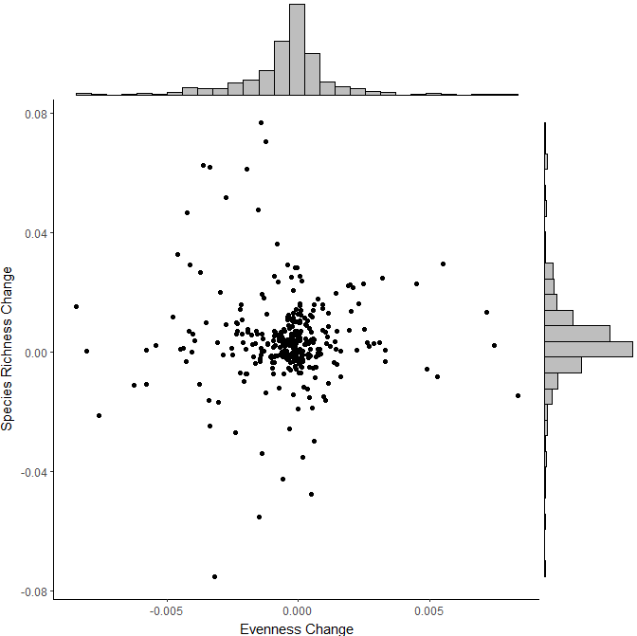

Figure . No relationship is evident between the change in the evenness of an assemblages and the change in species richness within the same assemblage. Frequency of rates of change in metrics are displayed as histograms along the outside of the plot.

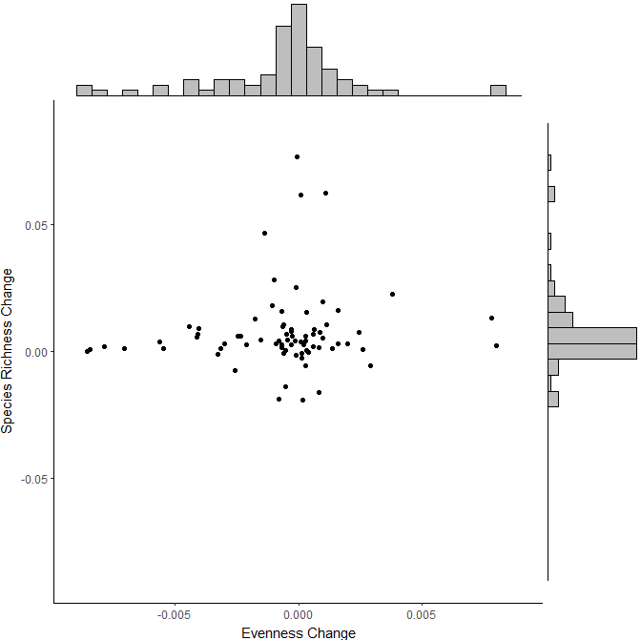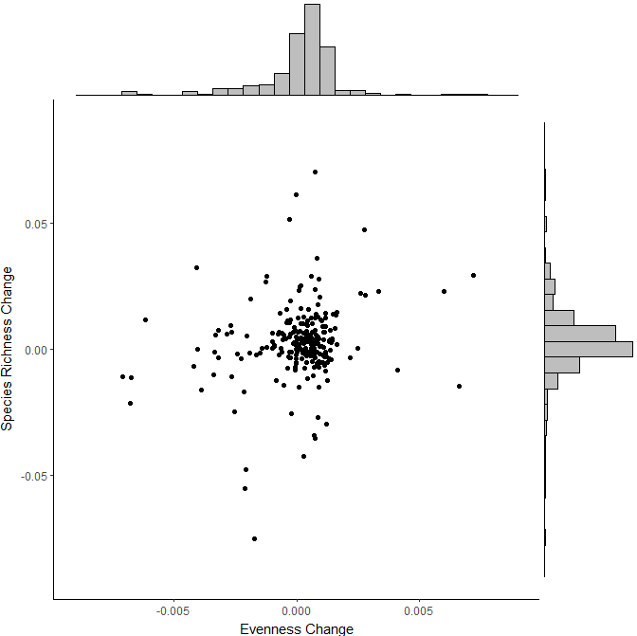

B

A

Figure . The relationship between evenness change and species richness change does not differ based on assemblage minimum species richness. The relationship between changes in metrics of the 76 assemblages with fewer than 20 species is shown in (A), and the relationship from the remaining 248 assemblages is shown in (B). Frequency of rates of change in metrics are displayed as histograms along the outside of the plot.

# Discussion

Our results demonstrate a lack of relationship between changes in different aspects of assemblage composition. You cannot infer change evenness by detecting a change in species richness, nor *vice versa,* despitethe mechanistic links between the two metrics suggested by (Rohr et al. 2016) and (Passy et al. 2017).

The community assembly theory suggested by (Passy et al. 2017) is not supported by our results. This suggests that factors other than shifts in species tolerance traits underpin changes within assemblages. The identities and rank orders of species within assemblages can be more significant than either changes in richness or evenness. Evenness and species richness may also respond differently to environmental factors (Soininen et al. 2012). This supposition is supported by the results of (Wang et al. 2017), who found evidence for species richness and evenness being effected by different main drivers within microbial assemblages, despite both metrics being positively correlated.

For monitoring change purposes, evenness and species richness can be considered orthogonal. Species richness measures alone are not informative enough to monitor all important biodiversity change in conservation.

# References

Avolio, M.L. et al., 2014. Changes in plant community composition, not diversity, during a decade of nitrogen and phosphorus additions drive above-ground productivity in a tallgrass prairie. *Journal of Ecology*, 102, pp.1649–1660.

Bates, D. et al., 2015. Fitting Linear Mixed-Effects Models Using lme4. *Journal of Statistical Software*, 67(1), pp.1–48.

Bock, C.E., Jones, Z.F. & Bock, J.H., 2007. Relationships between Species Richness, Eveness, and Abundance in a Southwestern Savanna. *Ecology*, 88(5), pp.1322–1327.

Chapin, F.S. et al., 2000. Consequences of changing biodiversity. *Nature*, 405(6783), pp.234–242. Available at: http://www.ncbi.nlm.nih.gov/pubmed/10821284.

Feio, M.J. et al., 2010. The influence of extreme climatic events and human disturbance on macroinvertebrate community patterns of a Mediterranean stream over 15 y. *Journal of the North American Benthological Society*, 29(4), pp.1397–1409. Available at: http://www.journals.uchicago.edu/doi/10.1899/09-158.1.

Gosselin, F., 2006. An assessment of the dependence of evenness indices on species richness. *Journal of Theoretical Biology*, 242(3), pp.591–597.

Gotelli, N.J. & Colwell, R.K., 2011. Estimating Species Richness. In A. E. Magurran & B. J. McGill, eds. *Biological Diversity*. Oxford University Press, pp. 39–54.

Gotelli, N.J. & Graves, G.R., 1996. Species diversity. In *Null Models in Ecology*. Smithsonian Institution Press, Washington, DC, USA.

Hill, M.O., 1973. Diversity and evenness: a unifying notation and its consequences. *Ecology*, 54(2), pp.427–432. Available at: http://www.esajournals.org/doi/abs/10.2307/1934352%5Cnhttp://www.esajournals.org/action/showCitFormats?doi=10.2307/1934352.

Hillebrand, H., Bennet, D.A. & Cadotte, M.W., 2008. Consequences of dominance: A review of Evenness Effects on Local and Regional Ecosystem Processes. *Ecology*, 89(6), pp.1510–1520.

Hooper, D.U. et al., 2005. Effects of biodiversity on ecosystem functioning: A consensus of current knowledge. *Ecological Monographs*, 75(1), pp.3–35. Available at: http://www.esajournals.org/doi/pdf/10.1890/04-0922.

Hulbert, S.H., 1971. The nonconcept of species diversity: a critique and alternative parameters. *Ecology*, (52), pp.577–585.

Jost, L., 2010. The relation between evenness and diversity. *Diversity*, 2(2), pp.207–232.

Kvålseth, T.O., 2015. Evenness indices once again: critical analysis of properties. *SpringerPlus*, 4, p.232. Available at: http://www.ncbi.nlm.nih.gov/pubmed/26020023%5Cnhttp://www.pubmedcentral.nih.gov/articlerender.fcgi?artid=PMC4439415.

Passy, S.I., 2016. Abundance Inequality in Freshwater Communities Has an Ecological Origin. *The American Naturalist*, 187(4), pp.502–516. Available at: http://www.journals.uchicago.edu/doi/10.1086/685424.

Passy, S.I. et al., 2017. Environmental filtering and taxonomic relatedness underlie the species richness–evenness relationship. *Hydrobiologia*, 787(1), pp.243–253.

Peet, R.K., 1974. The Measurement of Species Diversity. *Annual Review of Ecology and Systematics*, 5(1), pp.285–307. Available at: http://www.annualreviews.org/doi/abs/10.1146/annurev.es.05.110174.001441%0Ahttp://www.annualreviews.org/doi/10.1146/annurev.es.05.110174.001441.

R Core Team, 2016. R:A language and environment for statistical computing. Available at: https://www.r-project.org/.

Revermann, R. et al., 2016. Species richness and evenness respond to diverging land-use patterns - a cross-border study of dry tropical woodlands in southern Africa. *African Journal of Ecology*, pp.152–161.

Rohr, R.P. et al., 2016. Persist or Produce: A Community Trade-Off Tuned by Species Evenness. *The American Naturalist*, 188(4), pp.411–422. Available at: http://www.journals.uchicago.edu/doi/10.1086/688046.

Santini, L. et al., 2016. Assessing the suitability of diversity metrics to detect biodiversity change. *Biological Conservation*, pp.1–10.

Soininen, J., Passy, S. & Hillebrand, H., 2012. The relationship between species richness and evenness: A meta-analysis of studies across aquatic ecosystems. *Oecologia*, 169(3), pp.803–809.

Stirling, G. & Wilsey, B., 2001. Empirical Relationships between Species Richness, Evenness, and Proportional Diversity. *The American naturalist*, 158(3), pp.286–299.

Tilman, D., Isbell, F. & Cowles, J.M., 2014. Biodiversity and Ecosystem Functioning. *Annual Review of Ecology, Evolution, and Systematics*, 45(1), pp.471–493. Available at: http://www.annualreviews.org/doi/10.1146/annurev-ecolsys-120213-091917.

Wang, J. et al., 2017. Regional and global elevational patterns of microbial species richness and evenness. *Ecography*, 40(3), pp.393–402.

Ward, S.E. et al., 2010. Litter evenness influences short-term peatland decomposition processes. *Oecologia*, 164(2), pp.511–520.

Wilsey, B.J. & Potvin, C., 2000. Biodiversity and ecosystem functioning: the importance of species evenness in an old field. *Ecology*, 81(4), pp.887–893. Available at: http://www.researchgate.net/publication/235722835_Wilsey_B.J._and_C._Potvin._2000._Biodiversity_and_ecosystem_functioning_the_importance_of_species_evenness_in_an_old_field._Ecology_81887-893.

Wittebolle, L. et al., 2009. Initial community evenness favours functionality under selective stress. *Nature*, 458(7238), pp.623–626. Available at: http://www.nature.com/doifinder/10.1038/nature07840.

Wohlgemuth, D., Solan, M. & Godbold, J.A., 2016. Specific arrangements of species dominance can be more infuential than evenness in maintaining ecosystem process and function. *Scientific Reports*, 6(December), p.39325. Available at: http://dx.doi.org/10.1038/srep39325.

Yeboah, D., Chen, H.Y.H. & Kingston, S., 2016. Tree species richness decreases while species evenness increases with disturbance frequency in a natural boreal forest landscape. *Ecology and Evolution*, 6(3), pp.842–850.

Zhang, Y., Chen, H.Y.H. & Taylor, A., 2014. Multiple drivers of plant diversity in forest ecosystems. *Global Ecology and Biogeography*, 23(8), pp.885–893.